**МЕМОРИ**

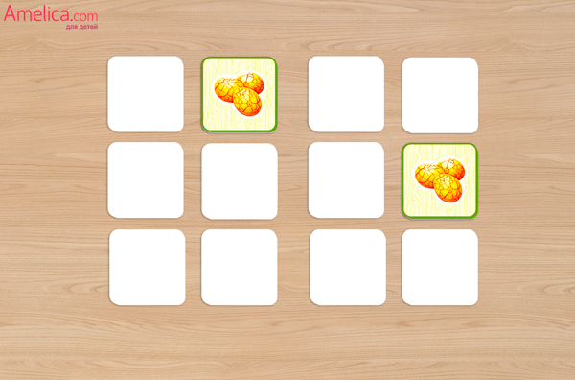

[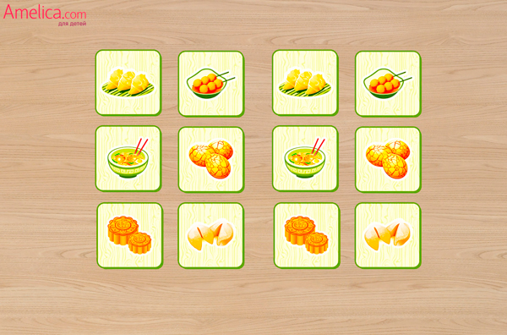](http://amelica.com/wp-content/uploads/2015/07/Igra_memori_dlya_detey_raspechatat_igra_naydi_paru_svoimi_rukami_6.jpg)